BACKGROUND
Repetitive stress injury resulting from standard keyboard use has become a major source of workplace injury. Split keyboards are often used both remedially and prophylactically in the case of wrist fatigue and injury. However, many office workers complain and sometimes outright refuse to use split keyboards, in spite of their ergonomic advantages. Reasons range from split keyboards being less comfortable to a loss of accuracy and speed in typing. Many people argue that they are more efficient using standard keyboards and would rather suffer the risk of new or continued wrist injury than switch to split keyboards.
In a subjective study of the differences in comfort between standard and ergonomic keyboard, the ergonomic keyboard was rated quite favorably (Keller, 2005). This study utilized questionnaires before and after typing tasks to rate comfort and effort.
Typing posture with a standard keyboard requires abduction or the arms, pronation of the forearms, wrist extension, ulnar deviation, and finger extension which elevate pressure in the carpal tunnels (Werner et al., 1997). CTS has been reported by people whose jobs require rapid finger movements and bent wrists such as people using standard keyboards (Hedge et al., 1996).
Previous work indicates that speed and accuracy both decrease while using a split keyboard as opposed to a standard keyboard (Fagarasanu et al, 2005). This study used older model split keyboards and research subjects who were accustomed to standard keyboards. Advances made in ergonomic keyboards since the publication of the study results bring into question the continued validity of the study.
The most obvious characteristic of modern ergonomic keyboards are the split down the middle of the alphabet keys. Another common characteristic is a negative slope. This slope has been found to significantly decrease dorsal wrist extension and increase the distance away from screen participants chose to sit at (Hedge & Powers, 1995).
OBJECTIVE
The objectives of this research are to determine if modern ergonomic split keyboards impair a user’s typing speed and accuracy, as compared to standard keyboards. The loss or increase in typing speed and accuracy will be quantified.
APPROACH
Readily available off-the-shelf keyboards will be used in this study. A standard Dell keyboard (Dell Thin USB Keyboard), which is commonly found on office desks, will be employed as the “standard keyboard.”
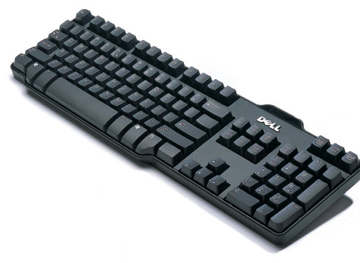
Figure 1: Standard keyboard used in this study
A Microsoft Natural Ergonomic Keyboard 4000, being commonly found and seemingly popular, will be used as the “ergonomic keyboard.”

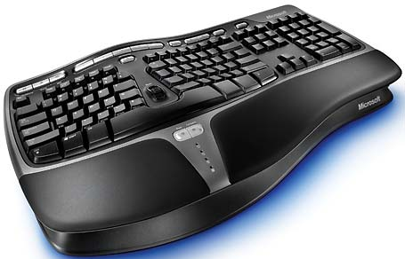
Figure 2: Ergonomic keyboard used in this study

A web-based typing program called Typing Master will be utilized to perform the typing analysis during this test (Typing Master, Inc., 1992). The test will measure the speed and accuracy of the participants as they type one of the five passages supplied by the program.
A pool of research participants was selected using normal techniques. Participants were required to know how to touch type, use computers on a daily basis in their work or schooling, and be familiar and comfortable with QWERTY-style keyboards. The participants chose two of the supplied stories to type with the standard and split keyboards. Each story was typed once with each keyboard. Two stories were used with the intent of minimize the learning effects during the study. The goal of having the participants switch the keyboards for the second trial was to try to minimize the effects from using two different stories with two different keyboards. It was thought that a particular story may expose the accuracy differences due to the different key layouts of the keyboards. By switching, it was thought the differences that may be present should be normalized. Each story was typed for 3 minutes. The typing program counted mistakes in a word-wise fashion. This meant that it did not allow participants to correct any mistakes once they advanced passed the word being typed and the error was counted the same no matter how many letters were wrong in the word.
RESULTS
Speed:
The results show that, in general, the participants had a reduction in their typing speed when switching over to the ergonomic keyboard. The participant data found in figure 3 was gathered by taking an average of the two runs for each keyboard. For participants 3 and 4, it can be seen from their error bars that this difference may not be statistically significant. The error bars relate the standard deviation for each participant’s results from their two runs. For a formal test with a larger sample population, it is suggested that a t-test be used to evaluate the results.

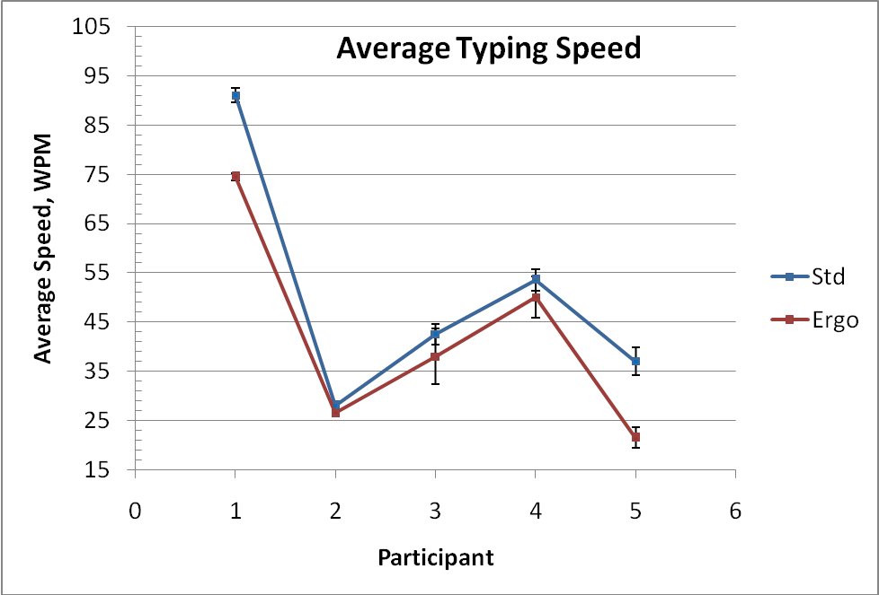
Figure 3: Average typing speed

Figure 4 shows that a reduction in the average speed of the participants is real. This data is the averaged speed reduction for each participant’s two runs. As can be observed, there is quite a range in the amount of speed reduction when looking at raw word-per-minute counts.
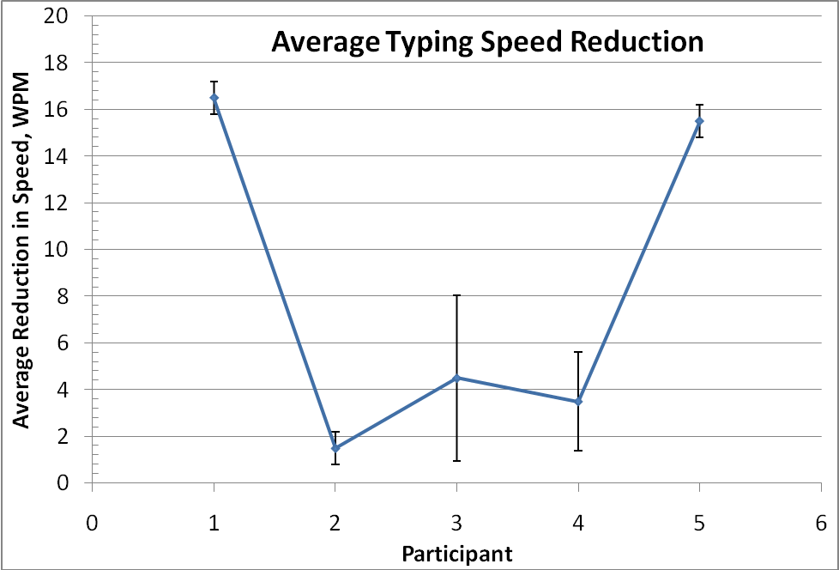
Figure 4: Average typing speed reduction
When the reductions are put into percentiles, as in Fig. 5, then the reductions are slightly more representative. The standard deviations show that this should not just be due to random effects, but is a repeatable observation.

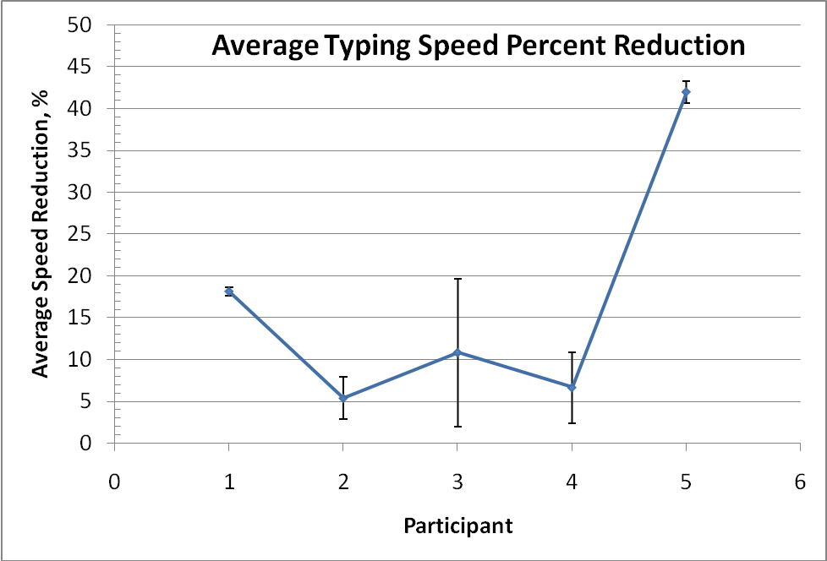
Figure 5: Average percent reduction in typing speed.
The standard deviation for participant 3 in Figures 4 and 5 is large. This participant showed a large change in performance between trial 1 and trial 2. This could be due to their learning effects of the keyboards, or of the use of the program. It may also indicate that one story was easier for them to type that the other, thus promoting a performance difference between runs.
Accuracy:
The results in Fig. 6 show some interesting things. First off, excluding participant 1, every participant has overlapping error bars. This would indicate that the differences observed may not be entirely significant.

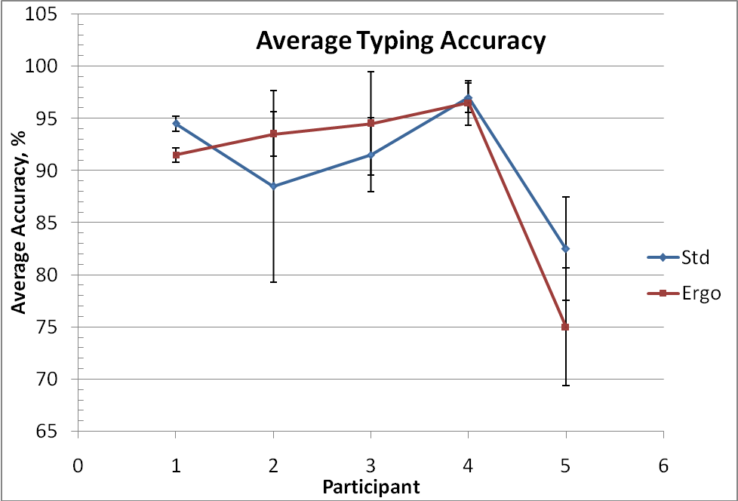
Figure 6: Average typing accuracy
Looking at the average typing accuracy reduction in Fig. 7 shows this another way. Two participants have error bars that clearly cross the horizontal axis. Given this is 20% of the sample population, a larger study would require more statistical analysis to verify the significance of the results.

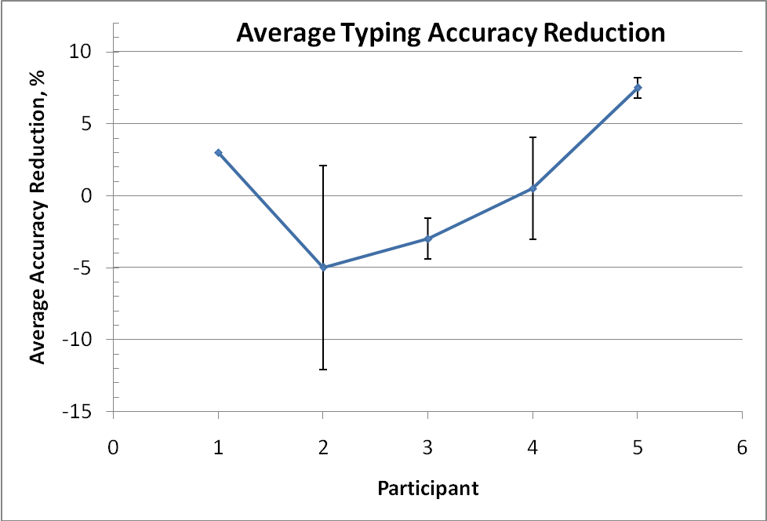
Figure 7: Reduction in average typing accuracy

Participant 3 again shows that while the accuracy results between tests were different enough to give large error bars (Figure 6), the differences between the keyboards for each trial were more consistent and yielded smaller error bars (Figure 7).

Group Performance:
Attention was then focused on overall group performance. The performance data in Table 1 was average over the entire group of participants. Looking at these overall averages, it can be seen that the speed reduction is only slightly greater than the standard deviation for this parameter. Looking next at accuracy, observation shows a standard deviation greater than the group average. This leads one to believe that the reduction in accuracy would not be of significance for an overall population, but be more individually based, as observed in Figures 6 and 7.

Table 1: Group Performance Averages
Group Performance Averages |  | Standard Deviation
Speed Reduction, (WPM) | 7.42 | 6.73
Speed Reduction, (%) | 15.4 | 13.8
Accuracy Reduction, (%) | 1.50 | 4.94
DISCUSSION
As expected, typing speed was reduced when switching from a standard to an ergonomic keyboard. However this reduction was only about 15% when averaged across the 5 participants. This means that a person who types about 2 hours a day will initially have to type for an additional 18 minutes per day to accomplish the same typing tasks. The accuracy of the group seemed to not show significant decreases, possibly giving no real consequences to typing tasks in the real world. One interesting thought on this is that those participants who had an increase in accuracy may have actually been looking down at their hands while typing. This could also affect speed results, particularly if their typing speed was at the threshold of what is possible with visual typing.
While there was no formal questionnaire to collect participants’ feelings about the keyboards, a number of participants expressed frustration in their decreased performance as they switched to the ergonomic keyboard. In one case the participant dropped out of the study prior to the second trial out of frustration.
This could affect typing speed also, so maybe the speed reduction isn’t truly represented until more time is spent on the ergo keyboard to where the users are not looking down.
FUTURE WORK
An expanded study in size and duration could help give more representative results. While this study focused on trying to quantify the initial change in typing performance when switching to an ergonomic keyboard, this may be hard data to extrapolate due to the rate of learning. Fagarasanu et al, report a 48% increase in the typing performance on two models of ergonomic keyboards after 8 hours of training (2005).
Another potentially interesting aspect comes from women being shown to be three times more likely than men to develop carpal tunnel syndrome (National Institute of Health, 2007). Possibly there is a stronger ergonomic correlation for the female population. Only one of the five participants in this study was female. Future research could focus on recruiting more women and determining if their results varied significantly from those of the male population.
There is also opportunity to expand the task itself. There are a myriad of different tasks one can perform on a computer and a great many of them require or allow the use of a keyboard. This study looked at typing speed in a simple word processing task. Further research could encompass less focused tasks such as spread sheets where the task requires shifting between keyboard and mouse and the use of function key and/or key combinations.
ACKNOWLEDGMENTS
The authors would like to thank the participants who generously donated their time to this study and Dr. Funk for his guidance through this project.
REFERENCES
Fagarasanu, M., Kumar, S., & Narayan, Y. (2005). The training effect of typing on two alternative keyboards. International Journal of Industrial Ergonomics. 35, 509-516.
Gerard, M.J., Jones, S.K., Smith, L.A., Thomas, R.E., & Wang, T. (1994). An ergonomic evaluation of the Kinesis Ergonomic Computer Keyboard. Ergonomics. 37 no. 10, 1161-1668.
Hedge, A., McCrobie, D., Morimoto, S., Rodriguez,S., & Land., B. (1996) Toward pain-free computing. Ergonomics in Design, 4(1), 4-10.
Hedge, A., & Ng, L. (2005). Effects of a Fixed-Angle, Split Keyboard with Center Trackball on Performance, Posture and Comfort Compared with a Conventional Keyboard and Mouse. Human Factors and Ergonomics Society Annual Meeting Proceedings. 957-957.
Hedge, A., & Powers, J.R. (1995). Wrist postures while keyboarding: effects of a negative slope keyboard system adn full motion forearm supports. Ergonomics. 38, 508-517.
Keller, E., Fleischer, R., & Strasser, H. (2004). Estimated and experienced subjective assessment of the ergonomic quality of a keyboard. Occupational Ergonomics. 4, 121 - 131.
National Institutes of Health, (2007, 11 19). Carpal Tunnel Syndrome Fact Sheet. Retrieved November 30, 2007, from National Institute of Neurological Disorders and Stroke Web site: http://www.ninds.nih.gov/disorders/carpal_tunnel/detail_carpal_tunnel.htm
Typing Master, Inc., (1992). Typing Test.com. Retrieved November 5, 2007, from Typing Test Web site: http://typingtest.com/
Werner, R., Armstrong, T.J., Aynard, M.K., 1997. Intracarpal canal pressure: The role of finger, hand, wrist and forearm position. Clinic Biometrics 12, 44-51.

