Optimization of Geometry and Beam Sizing for Load-bearing Structure

ME 517: Optimization in Design  
Winter 2008

**Team 1:**Brenton Gibson – gibson.b.d@gmail.com  
Douglas Van Bossuyt - drdougfir@gmail.com

# Abstract

Part of the design for a mechanical transfer-assist aisle chair is optimized for minimum mass. Motivation for and background on the design is given. An initial design problem model is presented and analyzed using monotonicity analysis to determine the adequacy of the model. The model is revised to achieve monotonicity. Several design optimization approaches are reviewed including KKT, the gradient method, Newton’s method, the generalized reduced gradient method, the simplex method, and genetic algorithms. A generalized reduced gradient method is employed to find the optimal design solution. Sensitivity analysis is performed and results are presented. Results are discussed with respect to the points of view of a design engineer, an engineering manager, and a customer. Conclusions and room for improvement are discussed.Table of Contents

Abstract 1

1 Introduction 3

2 Pre-optimization Analysis 8

3 Optimization Implementation Process 10

4 Post-optimization Analysis 15

5 Discussion of Results 15

5 Conclusion and Recommendation for Improvements 16

6 References 17

7 Appendix 18

# 1 Introduction

## 1.1 The Problem

Aisle chairs are the airline industry standard in mobility-impaired passenger transfer between the terminal and the aircraft. Current technology requires that a passenger be manually lifted by two boarding agents from a personal wheelchair onto the aisle chair, as can be seen in Figure 1. Once inside the aircraft, the process is reversed and the passenger is once again lifted – this time from the aisle chair into the airline seat. Significant risks of injury exist for the boarding agents and the passenger during the lifting process.



Figure 1: Manual Transfer Process to Aisle Chair

Recent research has found an alternative to manual lifting wherein a machine is substituted for boarding agents. By squeezing on and lifting from the rib cage, the risk of injury to the passenger’s arms is greatly reduced. Additionally, the boarding agents are not put in poor ergonomic positions for lifting large amounts of weight and the passenger is at much less risk of being dropped. Current research at the National Center for Accessible Transportation (NCAT) is focusing on integrating a mechanical lifting mechanism into an existing manual-lift aisle chair design. The prototype linkage is shown in Figure 2. A prototype lifting column attached to an aisle chair is shown in Figure 3. The transfer arm will be attached to the top of the lifting column on a bearing which will allow 360° rotation.

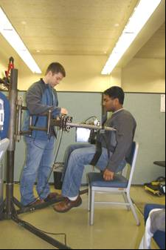

Figure 2: Mechanical Lifting Device

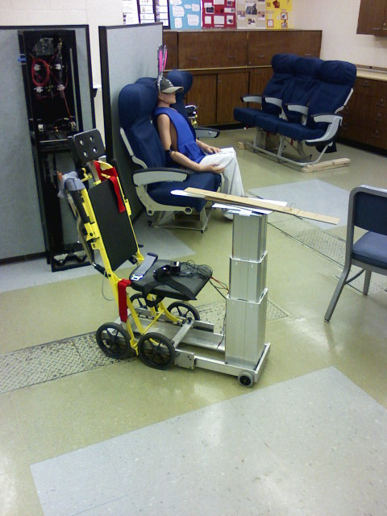One particular area of interest within the scope of aisle chair design work at NCAT is optimal mechanical transfer arm design. The current design is believed to be inefficient in material usage. A new design involving a simple truss structure has been proposed but optimum member sizing and geometric dimensions have not been determined. The design looks to minimize mass, thus minimizing cost of the assembly and cost of transport, should airlines decide or be mandated to carry the new design on airliners.

Figure 3: Lifting Column and Future Arm Attachment Point on Aisle Chair

## 1.2 The Proposed Solution

As six variables exist within the design problem, design optimization appears to be the most effective method of determining optimum design with minimal cost. The optimization model, with variables defined, can be seen in Figure 4. The force variable (F), defined as 350lbs, is induced by loading from the passenger being transferred and associated transfer mechanisms. Attempting to vary six variables via prototype construction or rote algebraic manipulation is time consuming and expensive. Using clever design optimization methods, the problem becomes reasonable.

## 1.3 Optimization Model

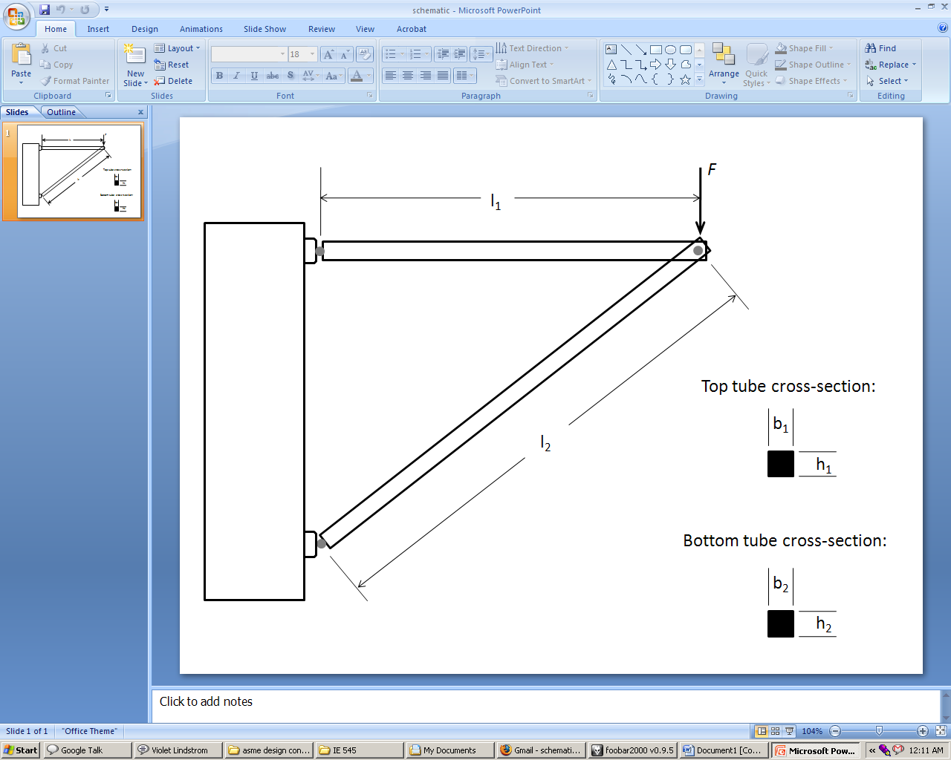

Figure 4: Idealized Design Model

**Construction of the Optimization Design Model**

Through preliminary analysis, it has been identified that buckling failure and yield failure are the two largest concerns. Pre-analysis was conducted using material selection analysis from methods by Ashby in Materials Selection in Mechanical Design. Via this analysis, it became clear that buckling and yield were the two largest concerns in the proposed structure. This analysis is not presented here for brevity of this document.

Additionally, several geometric constraints have been placed on the design. These constraints have been imposed due to space constraints within aircraft where the design will be used.

Finally, to reduce the complexity of this analysis, solid cross-section members are assumed. While other shapes would likely lead to lighter designs, accounting for different shape factors would quickly lead to the analysis process going beyond the abilities of the authors to calculate within the imposed time constraints. The design variables, as listed below, are allowed to vary infinitely within the design constraints. While it is true that materials do come in standard shapes and sizes, accounting for the possibility that air carriers might want to carry the aisle chair on board an airliner where every gram of weight saved directly affects the bottom line of the company led the authors to assume that machining rough stock to a specific size is acceptable.

**Design Variables:**

Free Variables:

* b1 = width of top member cross-section
* h1 = height of top member cross-section
* b2 = width of bottom member cross-section
* h2 = height of bottom member cross-section
* l2 = length of bottom member

These variables were chosen to vary based on their ability to affect the objective function. Varying the cross-sectional areas of the two members and length of the bottom member directly affects the mass of the assembly and the ability of the assembly to resist tensile and buckling failure. The cross-sectional areas of the two members are not held equal, as might be expected, because the NCAT design group suspects that a more optimal design can be found by allowing these variables to be independent of one another.

**Objective Function:**

The purpose of this optimization is to effectively minimize weight. For this analysis, it is assumed that both links will be made of the same material. With that in mind, the objective function is:

$$f_{min}\left(\overline{x}\right)= ρ(b_{1}h_{1}l_{1}+b_{2}h_{2}l_{2})$$

**Constraints:**

Force: $$F=350 lbs=158.76 kg=1557.44 N \\ H_{1}\left(\overline{x}\right)=F-1557.44N=0$$

Geometric:  
top tube is horizontal $$l_{1}=0.3 m \\ b_{1}≤0.1 m \\ h_{1}≤0.1 m \\ l_{2}≤1 m \\ b_{2}≤0.1 m \\ h_{2}≤0.1 m$$ $${H_{2}\left(\overline{x}\right)=l}_{1}-0.3 m=0 \\ {g_{1}\left(\overline{x}\right)=b}_{1}-0.1 m≤0 \\ {g_{2}\left(\overline{x}\right)=h}_{1}-0.1 m≤0 \\ {g_{3}\left(\overline{x}\right)=l}_{2}-1 m≤0 \\ {g_{4}\left(\overline{x}\right)=b}_{2}-0.1 m≤0 \\ {g_{5}\left(\overline{x}\right)=h}_{2}-0.1 m≤0$$

Yielding of top tube: $$σ_{1}=\frac{F_{1}}{A_{1}}=\frac{F_{1}}{b_{1}h_{1}} \\ F_{1}=\frac{F{l_{1}}^{2}}{l_{2}{\left({l_{2}}^{2}-{l_{1}}^{2}\right)}^{\frac{1}{2}}}$$

Buckling of bottom tube: $$F_{crit}=\frac{πEI_{2}}{{l_{2}}^{2}}=\frac{πEb_{2}{h_{2}}^{3}}{12{l_{2}}^{2}} \\ F_{2}=\frac{Fl_{1}}{{\left({l_{2}}^{2}-{l_{1}}^{2}\right)}^{\frac{1}{2}}}$$

Factor of Safety: $$n_{1}=\frac{S_{y}}{σ_{1}}≥3 \\ n_{2}=\frac{F_{crit}}{F_{2}}≥3$$ $${g_{6}\left(\overline{x}\right)=3-n}_{1}=3-\frac{S_{y}}{σ_{1}}≤0 \\ g_{7}\left(\overline{x}\right)={3-n}_{2}=3-\frac{F_{crit}}{F_{2}}≤0$$

**Assumptions:**

Several assumptions have been made in the process of preparing this proposal. They are listed and justified below.

1. All joints are pin joints – This assumption is made to simplify the design into a statically determinant problem.
2. All force will be concentrated at the pin joint – This assumption is made to simplify static analysis.
3. The members will only fail from tensile yielding and buckling – This assumption is made to limit the number of constraints to a reasonable level. Also, the two main failure modes that the NCAT design team believes will affect the design are buckling and yielding.

# 2 Pre-optimization Analysis

From monotonicity analysis, Table 1 results.

Table 1: Monotonicity Analysis of Design Problem

|  |  |  |  |  |  |  |
| --- | --- | --- | --- | --- | --- | --- |
|  | b1 | h1 | b2 | h2 | l2 | Activity |
| $$f\left(\overline{x}\right)$$ | + | + | + | + | + |  |
| $$H_{1}\left(\overline{x}\right)$$ |  |  |  |  |  |  |
| $$H_{2}\left(\overline{x}\right)$$ |  |  |  |  |  |  |
| $$g_{1}\left(\overline{x}\right)$$ | + |  |  |  |  | Inactive |
| $$g_{2}\left(\overline{x}\right)$$ |  | + |  |  |  | Inactive |
| $$g_{3}\left(\overline{x}\right)$$ |  |  |  |  | + | Inactive |
| $$g_{4}\left(\overline{x}\right)$$ |  |  | + |  |  | Inactive |
| $$g_{5}\left(\overline{x}\right)$$ |  |  |  | + |  | Inactive |
| $$g_{6}\left(\overline{x}\right)$$ | - | - |  |  |  | Active for b1, h1 by MP1 |
| $$g_{7}\left(\overline{x}\right)$$ |  |  | - | - | Need Investigation | Active for b2, h2 by MP1 |

As can be seen in the table, only $g_{6}\left(\overline{x}\right)$ and $g_{7}\left(\overline{x}\right)$ are active constraints. To determine if $g_{7}\left(\overline{x}\right)$ did in fact constrain $l_{2}$, numerical analysis was performed using MATLAB. Source code and other documentation can be seen in Appendix I. From numerical analysis, it becomes clear that $l_{2}$ has regional monotonicity. A MATLAB analysis, attached in Appendix 7.1, shows that when $l_{2}$ falls in the range of $0.3<l_{2}<0.4243$, the constraint is active for $l_{2}$. When $l_{2}>0.4243$, $g_{7}\left(\overline{x}\right)$ is inactive for $l_{2}$. It was also observed that a discontinuity exists when $l_{2}=0.3$, which is because this is when $l_{2}=l_{1}$. At this point, since the pin joints of $l_{2}$ and $l_{2}$ would be coincident, the device is not able to resist any vertical load. This means that another constraint, bounding $l_{2}$ from below, needs to be added. The geometry of the problem dictates that $l_{2}$ can be no smaller than $l_{1}$ for the structure to hold any load. Thus, a new constraint, $g_{8}\left(\overline{x}\right)$, must be created.

$$g_{8}\left(\overline{x}\right)=0.3-l_{2}≤0$$

$g_{8}\left(\overline{x}\right)$ provides the lower bound for $l_{2}$, as is reflected in Table 2.

Table 2: Updated Monotonicity Analysis of Design

|  |  |  |  |  |  |  |
| --- | --- | --- | --- | --- | --- | --- |
|  | b1 | h1 | b2 | h2 | l2 | Activity |
| $$f\left(\overline{x}\right)$$ | + | + | + | + | + |  |
| $$H_{1}\left(\overline{x}\right)$$ |  |  |  |  |  |  |
| $$H_{2}\left(\overline{x}\right)$$ |  |  |  |  |  |  |
| $$g_{1}\left(\overline{x}\right)$$ | + |  |  |  |  | Inactive |
| $$g_{2}\left(\overline{x}\right)$$ |  | + |  |  |  | Inactive |
| $$g_{3}\left(\overline{x}\right)$$ |  |  |  |  | + | Inactive |
| $$g_{4}\left(\overline{x}\right)$$ |  |  | + |  |  | Inactive |
| $$g_{5}\left(\overline{x}\right)$$ |  |  |  | + |  | Inactive |
| $$g_{6}\left(\overline{x}\right)$$ | - | - |  |  |  | Active for b1, h1 by MP1 |
| $$g_{7}\left(\overline{x}\right)$$ |  |  | - | - | - ($0.3<l_{2}<0.4243$)  + ($l_{2}>0.4243$) | Active for b2, h2, and l2 regionally by MP1 |
| $$g_{8}\left(\overline{x}\right)$$ |  |  |  |  | - | Active for l2 by MP1 |

Reviewing all of the constraints, it can be seen that $H_{1}\left(\overline{x}\right)$, $H_{2}\left(\overline{x}\right)$, $g_{1}\left(\overline{x}\right)$, $g_{2}\left(\overline{x}\right)$, $g_{3}\left(\overline{x}\right)$, $g_{4}\left(\overline{x}\right)$, and $g_{5}\left(\overline{x}\right)$ are inactive constraints and thus can be deleted from the analysis. The new optimization design model is:

Objective Function:

$$f_{min}\left(\overline{x}\right)= ρ(b_{1}h_{1}l_{1}+b_{2}h_{2}l_{2})$$

Constraints:

Yielding of top tube: $$σ_{1}=\frac{F_{1}}{A_{1}}=\frac{F_{1}}{b_{1}h_{1}} \\ F_{1}=\frac{F{l_{1}}^{2}}{l_{2}{\left({l_{2}}^{2}-{l_{1}}^{2}\right)}^{\frac{1}{2}}}$$

Buckling of bottom tube: $$F_{crit}=\frac{πEI_{2}}{{l_{2}}^{2}}=\frac{πEb_{2}{h_{2}}^{3}}{12{l_{2}}^{2}} \\ F_{2}=\frac{Fl_{1}}{{\left({l_{2}}^{2}-{l_{1}}^{2}\right)}^{\frac{1}{2}}}$$

Factor of Safety: $$n_{1}=\frac{S_{y}}{σ_{1}}≥3 \\ n_{2}=\frac{F_{crit}}{F_{2}}≥3$$ $${g_{6}\left(\overline{x}\right)=3-n}_{1}=3-\frac{S_{y}}{σ_{1}}≤0 \\ g_{7}\left(\overline{x}\right)={3-n}_{2}=3-\frac{F_{crit}}{F_{2}}≤0 \\ g_{8}\left(\overline{x}\right)=0.3-l_{2}≤0$$

**Justification of Constructed Model:**

Through the analysis presented above, the model, as presented, can be considered adequate for the purposes of pre-optimization analysis and for being well-bounded. By Monotonicity Principle 1, the model is well-constrained.

It should be noted that graphical techniques were not used due to the design problem having five variables. The authors are unable to successfully graphically represent the design problem and its boundary constraints concurrently in five dimensions.

# 3 Optimization Implementation Process

**KKT Analysis:**

Prior to performing KKT analysis, the authors conducted a combination analysis to judge how many potential combinations exist. The following formula was used:

$${{}_{n}^{}C}_{r}=\frac{n!}{n!\left(n-r\right)!} for 0≤r≤n where r=total design variables and n=total constraints$$

In the case of the model under analysis, there are a total of five design variables and eight total constraints. This lends:

$$\frac{8!}{8!\left(8-5\right)!}=219 possible solution combinations$$

Due to the daunting number of possible solution combinations using KKT and no automated solution checker being readily accessible to the authors of this paper, it was decided to not pursue KKT to directly find an optimum design solution.

**Possible Iterative Optimization Algorithms:**

Many different optimization methods exist. Several were examined during the course of determining the best algorithm for use on this design problem. Five are presented below.

**Gradient Method:**

The gradient method approaches finding an optimum solution to a design problem by finding the steepest slope. For each step, the direction of steepest slope is found and the new set of design variable points is selected along that slope at the end of the step interval. This method is very effective for problems that are of higher complexity than polynomials. However, there are some potential risks and drawbacks to this method. Local minima of size large enough to overwhelm the step interval can trap the algorithm into finding a local solution rather than a global solution. Likewise, long valleys within the design space can trap the algorithm, thus never yielding an optimal solution.

The condensed Taylor expression of the gradient algorithm is as follows:

$$f_{k+1}= f_{k}-αg_{k}^{T}g_{k}+(\frac{1}{2})α^{2}g_{k}^{T}{H_{k}g}_{k}$$

Where the step size $α$ is defined as:

$$α=\frac{g_{k}^{T}g_{k}}{g_{k}^{T}{H_{k}g}_{k}}$$

The gradient method does not handle boundary conditions. While this method is fairly straight-forward and easily implementable in Excel, it is not applicable to the design problem due to the boundary conditions problem. Generalized forms of the gradient method do take boundary conditions into account, however, and one is examined below.

**Newton’s Method:**

Newton’s Method employs a local linear approximation to fund the next set of potential optimal design points. By approximating the design model as a quadratic equation, computation time is reduced. The further the algorithm starts from the optimal design solution point, the quicker it will converge toward the solution while the closer the algorithm gets, the slower it goes. This is due to the step size decreasing as the optimal point is approached which is caused by higher order terms within the algorithm becoming more significant. As with other algorithms, Newton’s Method has its specific issues. For instance, if the Hessian approaches a non-invertible matrix, the inverted Hessian matrix can become unstable and cause the solution to diverge.

The generalized form of Newton’s Method, assuming that the Hessian is invertible, is:

$$x_{k+1}=x_{k}-H_{k}^{-1}g_{k}$$

Newton’s method is an unbounded algorithm in its pure form. To be able to take bounding conditions into account, the Lagrangian must be used and the Newton’s method is converted into the Generalized Newton’s Method. Thus, Newton’s Method, in this form, will not work for the design problem.

**Generalized Reduced Gradient Method:**

The generalized reduced gradient method operates under the same principles as the gradient method with a few important differences. This method allows nonlinear constraints and arbitrary bounds to be placed on the design variables. Using this method on linear problems will require more computing time than using the gradient method. It should be noted that the Excel solver function for design optimization problems uses an implementation of the generalized reduced gradient method. The Excel implementation can handle up to 200 design variables.

This method is very applicable to the design problem. It accounts for boundary conditions which none of the other methods reviewed up until this point can do. Also, it is a very easy method to implement as Excel makes the process nearly idiot-proof.

**Simplex Algorithm:**

The simplex algorithm is very useful for solving linear functions bounded by systems of linear inequalities. The linear inequalities define a polytope feasible region which the simplex algorithm uses by starting at a vertex and gradually move along the edges of the shape until the optimum solution vertex is reached. For linear functions and bounding conditions, the simplex method is very efficient. However, this algorithm is designed to find only one optimum point – even if others exist. Thus, other equally optimal points can be missed by using the classical simplex algorithm. Other, more recently developed algorithms based on simplex are able to find multiple optima.

While the simplex method does take into account boundary conditions and is well-suited for solving linear functions, such as the one present in the design problem, this method is not preferred as no easily accessible existing implementations of simplex are known by the authors.

**Genetic Algorithms:**

Genetic algorithms are based upon the principles of evolution. A design problem is abstracted into “chromosomes” which comprise a “creature” or “individual.” A population of creatures is created, each with different chromosome values. This is analogous to starting at different initial solution points for linear optimization algorithms. Each “generation,” otherwise known as an iteration or step, is examined for “fitness” of the creature. The fittest creatures are saved while the unfit creatures are discarded. The saved creatures then comprise the “parents” of the next generation of creatures. Chromosomes from each creature are mixed with those of other creatures to create the next generation. “Genetic mutations” are also introduced into the new creatures. Through many generations, an optimum set of creatures is evolved. The genetic algorithm will terminate when either:

* A solution that satisfies the minimum criteria is found
* A pre-determined number of generations is achieved
* Available computing time is reached
* The best creature’s fitness has or is reaching a plateau where no better creatures will be created

For an optimum solution, it is desirable that the algorithm terminates when no better creatures are created. However, this is a very rare occurrence when employing genetic algorithms. Indeed, most of the time, maximum available computing time is reached far before an optimal solution is found. Thus, one never really knows if the final solution is an optima without further sensitivity analysis.

While the genetic algorithm can account for boundary conditions and handles linear problems quite well, the authors have no experience using this method and are concerned that an optimum will not be found during the available computation time. Thus, the authors have decided to use the General Reduced Gradient Method available in Excel to find the optimum design variables for the design problem.

**Optimization Process:**

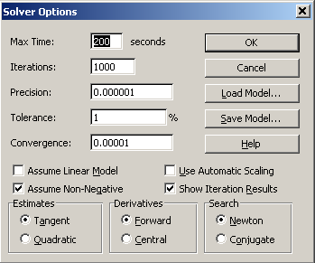For the presented problem, it was decided the most efficient way to find the optimization solution would be through the employment of Excel and the Solver add-in. The model was inputted in the form developed from the result of the pre-optimization analysis. All constraints were considered and the solver options were set as shown in Figure 5.  
Once the procedure was learned for the proper set-up and running of the solver, the results obtained were illuminating. The starting points for the free variables were set at their limits. This was 0.1m for the base and heights of the beams, and 0.3m for the length of beam 2. The initial value of the objective function, which was being minimized, was around 15kg. On the completion of several trials, meaning several thousand iterations were necessary for the convergence criteria to be met, the objective function fell to just under 0.008kg. The constraints bounding the solution were found to be $g_{2}\left(\overline{x}\right)$, $g_{6}\left(\overline{x}\right)$, and $g_{7}\left(\overline{x}\right)$. The fact that the height of beam 2 was optimally at its upper boundary did not make sense. The illuminating aspect of the results was that the optimal dimension for the base of beam 2 was found to be practically zero. Consideration of this result brought the realization that buckling was only accounted for in one dimension for beam 2.

Figure 5: Solver Settings Selected

For the results to be practical, it was necessary to also consider the second buckling dimension. The model was revised to take this into consideration through the addition of another constraint. This constraint took into account the beam had different end conditions when buckling in the other direction. The new constraint is:

$$g_{9}=3-\frac{π^{2}Eh_{2}{b_{2}}^{3}}{3{l_{2}}^{2}F_{2}}≤0$$

The solver was updated to include this constraint and calculations were started from the ending values of the previous solution. The results taken directly from the solver are given in Table 3.

Table 3: Excel Solver Results

|  |  |  |  |  |  |  |
| --- | --- | --- | --- | --- | --- | --- |
| Target Cell (Min) | | |  |  |  |  |
|  | **Cell** | **Name** | **Original Value** | **Final Value** |  |  |
|  | $B$25 | f(x) | 0.007565741 | 0.104814582 |  |  |
|  |  |  |  |  |  |  |
|  |  |  |  |  |  |  |
| Adjustable Cells | | |  |  |  |  |
|  | **Cell** | **Name** | **Original Value** | **Final Value** |  |  |
|  | $B$2 | b1 | 0.001828336 | 0.005530458 |  |  |
|  | $B$3 | h1 | 0.00344828 | 0.003448082 |  |  |
|  | $B$5 | b2 | 1.63486E-05 | 0.006621707 |  |  |
|  | $B$6 | h2 | 0.1 | 0.013243413 |  |  |
|  | $B$7 | l2 | 0.5570754 | 0.377441716 |  |  |
|  |  |  |  |  |  |  |
|  |  |  |  |  |  |  |
| Constraints | | |  |  |  |  |
|  | **Cell** | **Name** | **Cell Value** | **Formula** | **Status** | **Slack** |
|  | $B$20 | g7 | 1.65727E-08 | $B$20<=0 | Binding | 0 |
|  | $B$19 | g6 | 9.17893E-07 | $B$19<=0 | Binding | 0 |
|  | $B$22 | g9 | 1.67942E-08 | $B$22<=0 | Binding | 0 |
|  | $B$2 | b1 | 0.005530458 | $B$2<=0.1 | Not Binding | 0.094469542 |
|  | $B$3 | h1 | 0.003448082 | $B$3<=0.1 | Not Binding | 0.096551918 |
|  | $B$5 | b2 | 0.006621707 | $B$5<=0.1 | Not Binding | 0.093378293 |
|  | $B$6 | h2 | 0.013243413 | $B$6<=0.1 | Not Binding | 0.086756587 |
|  | $B$7 | l2 | 0.377441716 | $B$7<=1 | Not Binding | 0.622558284 |
|  | $B$7 | l2 | 0.377441716 | $B$7>=0.30000000000001 | Not Binding | 0.077441716 |

It can be seen that the final value of the objective function increased to 0.105kg, but the new result is actually realistic. The base of beam 2 is now not near zero, but was found to optimally be at 0.007m. It can also be observed that $g_{2}\left(\overline{x}\right)$ is no longer a binding constraint. The only constraints that are binding are the tensile and buckling constraints, $g_{6}\left(\overline{x}\right)$, $g_{7}\left(\overline{x}\right)$, and $g_{9}\left(\overline{x}\right)$, as was expected. It took about 4000 iterations to reach the results for the second trial.

# 4 Post-optimization Analysis

A sensitivity analysis was performed on the model to determine its robustness. A Six Sigma matrix was used for this analysis. In order to gain a more complete understanding of the model’s robustness, this analysis was completed with two different tolerances used for the variables, five and ten percent. A summary of the results is given in Table 4.

Table 4: Sensitivity Analysis Results

|  |  |  |
| --- | --- | --- |
|  | +/- 5% | +/- 10% |
| b1 | 0.00553 +/- 0.000277 m | 0.00553 +/- 0.000553 m |
| h1 | 0.003448 +/- 0.000172 m | 0.003448 +/- 0.000345 m |
| l1 | 0.3 +/- 0.015 m | 0.3 +/- 0.03 m |
| b2 | 0.006622 +/- 0.000331 m | 0.006622 +/- 0.000662 m |
| h2 | 0.013243 +/- 0.000662 m | 0.013243 +/- 0.001324 m |
| l2 | 0.377442 +/- 0.018872 m | 0.377442 +/- 0.037744 m |
| f(x) | 0.104815 +/- 9.69663E-07 kg | 0.104815 +/- 1.93933E-06 kg |

The results of this analysis show that the objective function, the mass of the system, does not vary widely when the free variables are allowed a tolerance value. A five percent tolerance on each of the free variables produced a variance of only 0.000925%. Upping the tolerance to 10% yielded an objective variance of 0.00185%. This leads to the conclusion that the design is very robust. If the objective function requires stringent specifications, having a relationship as observed here would make that easy. Manufacturing variances in the dimensions of the components would not be amplified in the objective function.

# 5 Discussion of Results

**Design Engineer’s Perspective**

As can be seen in section 3, the end results are very reasonable and were fairly straight-forward to achieve. Using the Excel equation solver to find the optimum design point was a very intelligent decision. Drawing upon the authors’ class work with Dr. Paasch, the most efficient solution with respect to the authors’ time was selected.

Examining the results of the final solution, a design engineer should be quite happy. The mass was found to only be 0.105kg which is quite reasonable when viewed in the context of the larger aisle chair design problem. Such a small mass addition to the aisle chair approaches inconsequential when compared against the power source – two closed-cell lead acid car batteries each weighing in excess of 20 kg.

**Engineering Manager’s Perspective**

Most engineering managers are primarily concerned with keeping projects on time and under budget while meeting customer and upper management expectations. The engineering manager would most likely have questioned the design engineer’s need to perform optimization analysis, knowing that optimization can often become computing and time-intensive. After proper justification by the design engineer, the engineering manager would most likely set a limit for allowable computing time and engineering time.

With that taken into account, the engineering manager would be quite pleased with the result. Computing time was kept to a minimum, with only approximately 4000 iterations needed for the final solution. Taking into account that a design engineer proposing design optimization would already be familiar with conducting design optimizations, it can also be assumed that this problem would have been solved in relatively short order. This was not the case, however, for the authors as they had limited experience prior to tackling this design problem.

Finally, the engineering manager would be happy knowing that the customer would be happy with the minimized mass of the design. As discussed previously, every gram saved is a monetary savings for the airlines.

**Customer’s Perspective**

The customer would be happy with the design resulting from the optimization analysis performed above. Mass was minimized in a rigorous and analytic way. The customer can rest assured that 0.105kg is the lightest possible design taking into account the constraints placed upon the design. Also, knowing which design constraints turned out to be active will tell the customer what constraints might be considered to be loosened to reduce mass even further.

# 5 Conclusion and Recommendation for Improvements

This project provided a good venue for the solidification of the learning of optimality techniques. Monotonicity analysis is useful for an initial quick check of the boundedness of the model. Getting a quick idea of the model’s validity is very useful and saves time later. The Karush-Kuhn-Tucker (KKT) method proves to be extremely tedious for anything beyond the simplest of models. It was deemed not worthwhile to execute KKT on the model under study due to the high amount of manual computation necessary. Many different iterative approaches exist for the calculation of the optimal solution. The one used for this project was chosen for the efficiency in which it allowed the result to be reached. The Generalized Reduced Gradient Method was implemented through the use of the Solver in Excel. Even with this aid, it was important to utilize common sense when reviewing the results. Careful observation revealed an oversight in the model, which was easily updated in order to achieve a final optimal solution. The final model and its solution were put under the scrutiny of a Sensitivity Analysis. This proved to reveal a very robust model.

The process taken for this project was reasonably smooth. Only slight changes would be made to the overall process if given the jurisdiction. For one, given the number of design variables and constraints, time would not have been spent looking at the feasibility of the KKT method. It was obvious before actually calculating the possible combinations that there was going to be a tremendous amount of monotonous work involved if this method was fully utilized. Also, it would be beneficial to have more exposure and access to commercial software packages that would aid in the calculation of the optimal design. Given this ability, it is possible a different solution method would have been used for this project, such as a Genetic Algorithm. This exposure would also be especially useful later on, as applying optimality techniques to the majority of real-world design problems would create a more sophisticated model than the one analyzed for this project. All in all, this was a good exercise to show what can be expected when taking a design through an optimization process.

# 6 References

Ashby, M., Materials Selection in Mechanical Design. 3rd Ed. 2005. Elsevier Butterworth-Heinemann, Burlington, Massachusetts.

Mathematical Programming Glossary. INFORMS Computing Society. Accessed March 1, 2008. http://glossary.computing.society.informs.org/

Papalambros, P., and Wilde, D., Principles of Optimal Design – Modeling and Computation. 2nd Ed. 2000. Cambridge University Press, New York.

Scheaffer, R., and McClave, J., Probability and Statistics for Engineers. 4th Ed. 1995. Duxbury Press, Belmont, California.

Shigley, J., Mischke, C., Budynas, R. Mechanical Engineering Design. 7th Ed. 2004. Mc Graw-Hill, Singapore.

Solver Technology – Linear Programming and Quadratic Programming. Frontline Systems, Inc. Accessed February 27, 2008. <http://www.solver.com/technology2.htm>

# 7 Appendix

## 7.1 MATLAB Code:

x = 0.4:.001:2;

k = 38617;

z = -k./(x.*(-0.3^2+x.^2).^(1/2))+(2*k.*(-0.3^2+x.^2).^(1/2))./(x.^3);

plot(x,z)

xlabel('l2');

ylabel('g7');

title('Monotonically increasing or decreasing?');

Resulting Plot:

